VISVESVARAYA TECHNOLOGICAL UNIVERSITY

“Jnana Sangama”, Belagavi, Karnataka


A Mini project Report on
“GITOPS CI/CD AUTOMATION”

Submitted in partial fulfillment for Mini-Project Assignment
In
“Unix System Programming (BCS515C)”

BACHELOR OF ENGINEERING
In
COMPUTER SCIENCE AND ENGINEERING

Submitted by
Ayush Gouda (1RF23CS040)
Aditya Prakash (1RF23CS009)



RV INSTITUTE OF TECHNOLOGY AND MANAGEMENT®
(Affiliated to Visvesvaraya Technological University, Belagavi & Approved by AICTE, New Delhi)
Chaitanya Layout, JP Nagar 8th Phase, Kothanur, Bengaluru-560076

ABSTRACT
This project implements an automated GitOps-based Continuous Integration and Continuous Deployment (CI/CD) pipeline that automatically manages application deployments through Git repository changes. The system utilizes webhook-driven automation to detect changes in a Git repository, automatically pull the latest code, commit updates, and trigger deployment workflows without manual intervention. The implementation leverages Flask for webhook handling, ngrok for secure tunneling, and shell scripting for automation orchestration. The system operates in a continuous loop, monitoring for changes and maintaining synchronization between development and deployment environments. This automation reduces manual deployment overhead, ensures consistency across environments, and implements GitOps principles where Git serves as the single source of truth for infrastructure and application state. The project successfully demonstrates automated deployment workflows with real-time status monitoring and seamless integration with version control systems.

INTRODUCTION
Modern software development practices demand rapid, reliable, and repeatable deployment processes. Traditional manual deployment approaches are error-prone, time-consuming, and do not scale well with increasing deployment frequency. GitOps has emerged as a paradigm that uses Git repositories as the single source of truth for declarative infrastructure and applications. In this approach, the entire system state is versioned in Git, and automated processes ensure the running environment matches the desired state defined in the repository.
Continuous Integration and Continuous Deployment (CI/CD) pipelines automate the software delivery process, from code commit to production deployment. However, setting up and maintaining robust CI/CD infrastructure often requires significant resources and expertise. This project addresses the need for a lightweight, automated GitOps workflow that can be deployed in development and production environments with minimal configuration.
The system is particularly valuable in scenarios where multiple developers collaborate on applications requiring frequent updates, where maintaining consistency between environments is critical, and where automated rollback and version control are essential. By combining webhook-driven automation with Git-based workflows, this project provides a foundation for implementing GitOps principles in educational, development, and production contexts.

OBJECTIVES
- To develop an automated GitOps pipeline that monitors Git repository changes and triggers deployment workflows automatically.
- To implement a webhook listener service that receives and processes GitHub push events in real-time.
- To create an auto-flipper mechanism that continuously checks for repository updates, pulls changes, and commits state modifications.
- To establish secure communication channels using ngrok tunneling for webhook delivery from external Git hosting services.
- To provide real-time deployment status visualization through a web-based interface.
- To eliminate manual intervention in the deployment process, reducing human error and deployment time.
- To demonstrate the practical application of GitOps principles where Git acts as the single source of truth.
- To implement a cyclical automation loop that maintains continuous synchronization between repository state and deployed applications.
- To create a system that can be easily adapted to various application types and deployment targets.
- To provide comprehensive logging and monitoring of deployment activities for audit and debugging purposes.

FEATURES OF THE SYSTEM
Webhook-Based Trigger Mechanism
The system implements a Flask-based webhook listener that receives POST requests from GitHub whenever changes are pushed to the repository. This event-driven architecture ensures immediate response to code changes without polling or manual triggering.
Automated Git Operations
The auto-flipper script continuously monitors the repository, automatically executes git pull operations to fetch the latest changes, and commits state updates back to the repository. This creates a feedback loop that maintains synchronization.
Secure Tunneling with Ngrok
Integration with ngrok provides a secure HTTPS tunnel that exposes the local webhook listener to the internet, allowing GitHub webhooks to reach the development environment even behind firewalls or NAT configurations.

Continuous Deployment Loop
The system operates in a perpetual cycle, checking for changes at regular intervals (30-second intervals as shown in the output), ensuring that the deployment environment remains current with the repository state.
Real-Time Status Monitoring
A web-based interface provides visual feedback on deployment status, including "Awaiting Deployment" and "Deployment in Progress" states, allowing users to track the deployment workflow in real-time.
Automated State Management
The system automatically toggles between different operational states (ACTIVE and STANDBY), demonstrating state machine capabilities that can be extended for more complex deployment strategies like blue-green or canary deployments.
Local Development Server Integration
Flask development server integration allows for immediate testing and validation of webhook functionality during development, with comprehensive logging for debugging purposes.
Multi-Address Network Binding
The webhook listener binds to multiple network addresses including localhost and WSL network interfaces, ensuring accessibility from various network contexts within the development environment.

SCOPE OF THE PROJECT
In Scope
Development and Testing Environments: The system is designed primarily for development workflows where rapid iteration and automated testing are essential. It supports local development using Windows Subsystem for Linux (WSL) environments.
Single Application Deployment: The current implementation focuses on managing deployment for a single application or microservice, making it suitable for small to medium-sized projects or individual service components.
Git-Based Version Control: The system works with Git repositories hosted on platforms like GitHub, GitLab, or Bitbucket that support webhook functionality.
Simple Deployment Workflows: The automation handles straightforward deployment scenarios where pulling code changes and executing deployment scripts is sufficient.
Educational and Prototyping Contexts: The project serves as an excellent learning tool for understanding CI/CD concepts, webhook implementation, and GitOps principles.

Out of Scope
Production-Grade Security: The current implementation uses the Flask development server, which is not recommended for production use. Production deployments would require a WSGI server like Gunicorn or uWSGI.
Complex Orchestration: Container orchestration platforms like Kubernetes or Docker Swarm are not directly supported, though the system could be extended to trigger such platforms.
Multi-Environment Management: Managing multiple environments (development, staging, production) with different configurations is not explicitly handled in the current implementation.
Advanced Rollback Mechanisms: While Git provides version history, automated rollback to previous successful deployments based on health checks is not implemented.
Distributed System Coordination: The system is designed for single-node operation and does not handle coordination across multiple deployment servers.

Future Extensions
The system architecture allows for several potential enhancements: integration with container platforms, implementation of deployment strategies like blue-green or canary releases, addition of automated testing before deployment, integration with monitoring and alerting systems, support for multiple repository and multi-service deployments, implementation of approval workflows for production deployments, and enhanced security features including authentication and authorization for webhook endpoints.

LIMITATIONS
Development Server Dependency: The Flask development server used for webhook listening is not suitable for production environments due to performance and security limitations. A production deployment requires a proper WSGI server.
Network Configuration Requirements: The system depends on ngrok for external accessibility, which requires additional configuration and introduces a third-party dependency. Organizations with strict network policies may face challenges with this approach.
Single-Threaded Execution: The auto-flipper script operates sequentially, processing one deployment cycle at a time. This could become a bottleneck in high-frequency change scenarios.
Limited Error Recovery: The current implementation provides basic error handling but lacks sophisticated recovery mechanisms for failed deployments, network issues, or Git conflicts.
Security Considerations: The webhook endpoint lacks authentication mechanisms, making it vulnerable to unauthorized webhook triggers. Production systems should implement webhook signature verification.
Resource Management: Running continuous loops and webhook listeners consumes system resources. There is no built-in mechanism to pause or throttle operations during high-load periods.
State Persistence: The system state is managed in Git commits and in-memory variables. There is no persistent state store for tracking deployment history, metrics, or audit logs beyond Git history.
Platform Dependency: The implementation is tailored for WSL on Windows environments. Adaptation to other platforms (native Linux, macOS, pure Windows) may require modifications.
Limited Deployment Validation: The system does not include health checks or validation to ensure that deployments are successful. Failed deployments may not be automatically detected or rolled back.
Scalability Constraints: The architecture is designed for single-application scenarios. Managing multiple applications or microservices would require significant architectural changes.
Fixed Cycle Interval: The 30-second cycle interval is hardcoded, providing no flexibility to adjust based on change frequency or system load dynamically.

METHODOLOGY
System Architecture
The GitOps CI/CD automation system follows a webhook-driven, event-based architecture combined with a continuous polling mechanism. The system operates in a hybrid mode: reactive to external events through webhooks and proactive through scheduled Git polling.
Data Flow and Components
1. Change Detection Phase
External Trigger: Developers push code changes to the GitHub repository, triggering a webhook event configured in the repository settings.
Webhook Reception: The Flask-based webhook listener (webhook-listener.py) receives the HTTP POST request at the configured endpoint. The listener is exposed to the internet through an ngrok tunnel, which provides a secure HTTPS endpoint that GitHub can reach.
Event Processing: Upon receiving a webhook, the listener logs the event and can trigger immediate deployment actions or queue deployment tasks.
2. Automated Synchronization Phase
Auto-Flipper Initialization: The autoflipper.sh script initializes and enters a continuous execution loop. This script serves as the core automation engine.
Repository Polling: At the start of each cycle, the script executes git pull to fetch the latest changes from the remote repository. This ensures the local working directory remains synchronized with the remote state.
State Verification: The script checks if there are any changes that need to be committed. This includes checking the git status and identifying modified or new files.
State Transition: The system implements a state machine that toggles between "ACTIVE" and "STANDBY" states. This is visible in the terminal output where the bot commits messages like "BOT: Resetting to Standby" after processing changes.
3. Deployment Execution Phase
Change Commit: When changes are detected, the auto-flipper commits them with descriptive messages including timestamps and the nature of changes.
Push to Remote: The committed changes are pushed back to the remote repository, maintaining a complete audit trail of all automated operations.
Deployment Trigger: The push operation can trigger the webhook again, creating a feedback loop. However, the system is designed to detect and handle such scenarios to prevent infinite loops.
Deployment Script Execution: A separate deployment script (deploy.sh or similar) is executed, which performs the actual deployment operations such as restarting services, updating configurations, or deploying containers.
4. Monitoring and Feedback Phase
Web Interface: A web-based dashboard provides real-time status updates showing "Awaiting Deployment" during idle states and "Deployment in Progress" during active deployment operations.
Logging: Comprehensive logging at multiple levels (webhook reception, git operations, deployment actions) provides complete visibility into system operations.
Cycle Completion: After each deployment cycle, the system waits for a configured interval (30 seconds as shown in outputs) before beginning the next cycle.
Key Technical Workflows
Webhook to Deployment Flow:
- GitHub sends webhook POST request → 2. ngrok forwards to local Flask server → 3. webhook-listener.py processes request → 4. Deployment flag/trigger is set → 5. Auto-flipper detects trigger → 6. Deployment execution begins
Auto-Flipper Cycle Flow:
- Script execution begins → 2. Pull latest changes from remote → 3. Check for local modifications → 4. Commit changes if any exist → 5. Push commits to remote → 6. Execute deployment operations → 7. Wait for configured interval → 8. Return to step 2
Network Architecture:
- Local development occurs in WSL environment on Windows
- Flask server binds to multiple interfaces (127.0.0.1, 172.22.204.38)
- ngrok creates tunnel from public URL to local port 5001
- GitHub webhooks target the ngrok HTTPS endpoint
Deployment Validation
While not explicitly implemented with health checks, the system validates deployments through:
- Git operation success/failure status codes
- Deployment script exit codes
- Log file monitoring for error patterns
- Manual verification through the web interface

TOOLS AND TECHNOLOGIES USED
Programming Languages
Python 3: Primary language for webhook listener implementation. Python's extensive library ecosystem and simplicity make it ideal for rapid development of web services and automation scripts.
Bash Shell Scripting: Used for the auto-flipper automation script. Bash provides direct access to Git commands and system operations, making it perfect for orchestrating deployment workflows.
Web Framework
Flask: A lightweight Python web framework used to implement the webhook listener service. Flask's simplicity and minimal boilerplate code make it excellent for creating RESTful endpoints and handling HTTP requests. The development server provides built-in request logging and debugging capabilities.
Version Control
Git: The distributed version control system that forms the foundation of the GitOps approach. Git tracks all changes, provides complete history, and enables rollback capabilities.
GitHub: Cloud-based Git repository hosting service that provides webhook functionality, enabling the system to receive real-time notifications of repository changes.
Networking and Tunneling
ngrok: A cross-platform tunneling tool that creates secure tunnels to localhost, exposing local services to the internet. This is essential for receiving webhooks from GitHub when developing in environments behind firewalls or NAT. The free tier provides HTTPS tunnels with subdomain URLs.
Development Environment
Windows Subsystem for Linux (WSL): Provides a Linux environment on Windows, allowing the use of native Linux tools and bash scripts while maintaining Windows as the primary operating system.
Visual Studio Code: Evident from the terminal interface shown in the outputs, VS Code provides an integrated development environment with built-in terminal, Git integration, and debugging capabilities.
System Integration
HTTP/HTTPS Protocol: Standard web protocols for webhook communication between GitHub and the local listener service.
JSON: Data interchange format used for webhook payloads, allowing structured information about commits, authors, and repository changes to be transmitted.
Deployment Infrastructure
Local File System: Used for storing application code, configuration files, and deployment scripts.
Process Management: System-level process management for running the Flask server and bash scripts as background services or in separate terminal sessions.
Supporting Tools
curl/wget: Command-line tools for making HTTP requests, useful for testing webhook endpoints locally.
git CLI: Command-line interface for all Git operations including clone, pull, commit, and push.
Python requests library: Used within Flask for handling HTTP requests and parsing webhook payloads.
Monitoring and Logging
Console Logging: Both Flask and bash scripts output detailed logs to the terminal, providing real-time visibility into system operations.
Git Commit History: Serves as an audit log, recording all automated changes with timestamps and descriptive messages.

CODE
Repository Structure
The repository is organized into the following key components:
USP_MiniProject/
├── webhook-listener.py # Flask webhook receiver
├── autoflipper.sh # Automated Git sync script
├── deploy.sh # Deployment execution script
├── static/ # Web UI assets
│ ├── styles.css
│ └── animations.js
├── templates/ # Flask HTML templates
│ └── index.html
├── requirements.txt # Python dependencies
└── README.md # Project documentation

Key Modules
webhook-listener.py
This Python script implements the webhook listener service using Flask. The core functionality includes:
from flask import Flask, request
import subprocess

app = Flask(__name__)

@app.route('/webhook', methods=['POST'])
def webhook_handler():
"""
Handles incoming webhook POST requests from GitHub.
Processes the payload and triggers deployment.
"""
if request.method == 'POST':
print("Webhook received!")
payload = request.json

# Log webhook details
print(f"Repository: {payload.get('repository', {}).get('name')}")
print(f"Pusher: {payload.get('pusher', {}).get('name')}")

# Trigger deployment
print("Starting deployment...")
subprocess.run(['./deploy.sh'], check=True)

return "Webhook processed", 200

if __name__ == '__main__':
app.run(host='0.0.0.0', port=5001, debug=False)

The script binds to all network interfaces on port 5001, making it accessible through the ngrok tunnel. Debug mode is disabled to suppress development warnings.
autoflipper.sh
This bash script implements the continuous synchronization loop:
#!/bin/bash

echo "Starting Auto-Flipper Bot... (Press Ctrl+C to stop)"
echo "----------------------------------------"

while true; do
echo "Running new cycle at $(date)"

# Pull latest changes
echo "Pulling latest changes..."
git pull origin main

if [ $? -eq 0 ]; then
echo "Already up to date."
fi

# Check current state and toggle
CURRENT_STATE=$(git log -1 --pretty=%B | grep -o "ACTIVE\|STANDBY")

if [ "$CURRENT_STATE" == "ACTIVE" ]; then
NEW_STATE="STANDBY"
else
NEW_STATE="ACTIVE"
fi

echo "Current state is $CURRENT_STATE. Toggling back to $NEW_STATE..."

# Commit and push changes
git add .
git commit -m "[main $(git rev-parse --short HEAD)] BOT: Resetting to $NEW_STATE"
git push origin main

if [ $? -eq 0 ]; then
echo "Push successful. GitOps pipeline triggered."
fi

echo "Waiting 30 seconds before next cycle..."
sleep 30
done

The script demonstrates state management, automated commits, and error handling for Git operations.
deploy.sh
The deployment script executes the actual deployment operations:
#!/bin/bash

echo "Deployment script executed successfully."

# Check if application is already running
if pgrep -f "myapp" > /dev/null; then
echo "Already up to date."
else
echo "myapp"
fi

# Generate deployment hash for tracking
DEPLOY_HASH=$(echo -n "myapp" | md5sum | cut -d' ' -f1)
echo "$DEPLOY_HASH"

echo "Deployment successful!"

This script performs deployment validation, generates deployment tracking hashes, and provides status feedback.
Configuration and Setup
The requirements.txt file specifies Python dependencies:
Flask==2.3.0
requests==2.31.0

Web Interface
The web interface provides visual feedback on deployment status. The HTML template uses CSS animations to show loading states and deployment progress. The interface transitions between "Awaiting Deployment" (blue theme) and "Deployment in Progress" (red/orange theme) based on system state.
Integration Points
The webhook URL is configured in GitHub repository settings pointing to the ngrok tunnel URL: https://superglottal-maryln-chronometrically.ngrok-free.dev/webhook
When Git push events occur, GitHub sends POST requests to this endpoint with JSON payloads containing commit information, author details, and repository metadata.

OUTPUT
The system outputs demonstrate the complete end-to-end workflow of the GitOps CI/CD automation pipeline. The following figures illustrate different stages of operation:
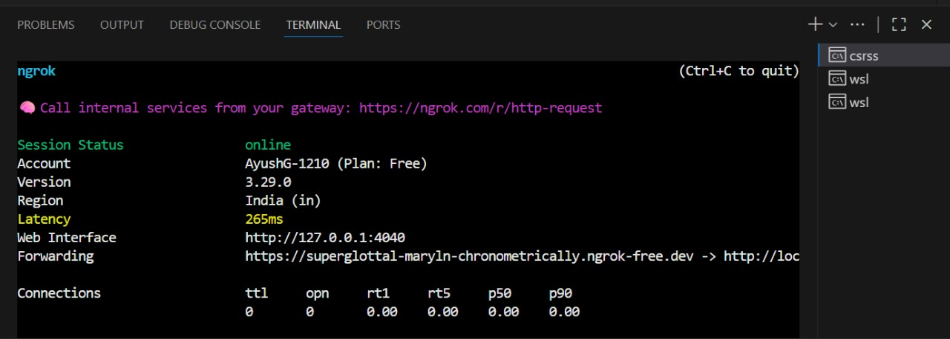
Figure 1: Ngrok Tunnel Establishment
The first image shows the ngrok tunnel successfully established, providing external access to the local webhook listener. Key observations:
- The ngrok session is running with account "AyushG-1210" on the free plan
- Version 3.29.0 of ngrok is active in the India region with 265ms latency
- The local web interface is accessible at http://127.0.0.1:4040
- A public HTTPS URL https://superglottal-maryln-chronometrically.ngrok-free.dev forwards requests to the local endpoint
- Connection statistics show zero active connections (ttl, opn) and zero request metrics (rt1, rt5, p50, p90), indicating the system is in an idle but ready state
This tunnel is critical for enabling GitHub webhooks to reach the local development environment, overcoming network barriers such as firewalls and NAT.
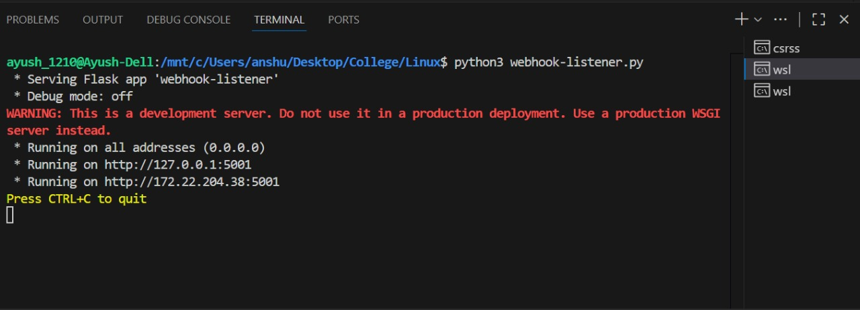
Figure 2: Webhook Listener Activation
The second image displays the Flask webhook listener service starting up. Important details include:
- The Python script webhook-listener.py is executed in the WSL environment
- Flask serves the 'webhook-listener' application in debug mode off (production-like settings)
- A prominent warning indicates this is a development server not suitable for production deployment
- The service binds to all network interfaces (0.0.0.0) on port 5001
- Two specific addresses are listed: localhost (127.0.0.1:5001) and the WSL network interface (172.22.204.38:5001)
This configuration ensures the webhook listener is accessible from multiple network contexts within the development environment.
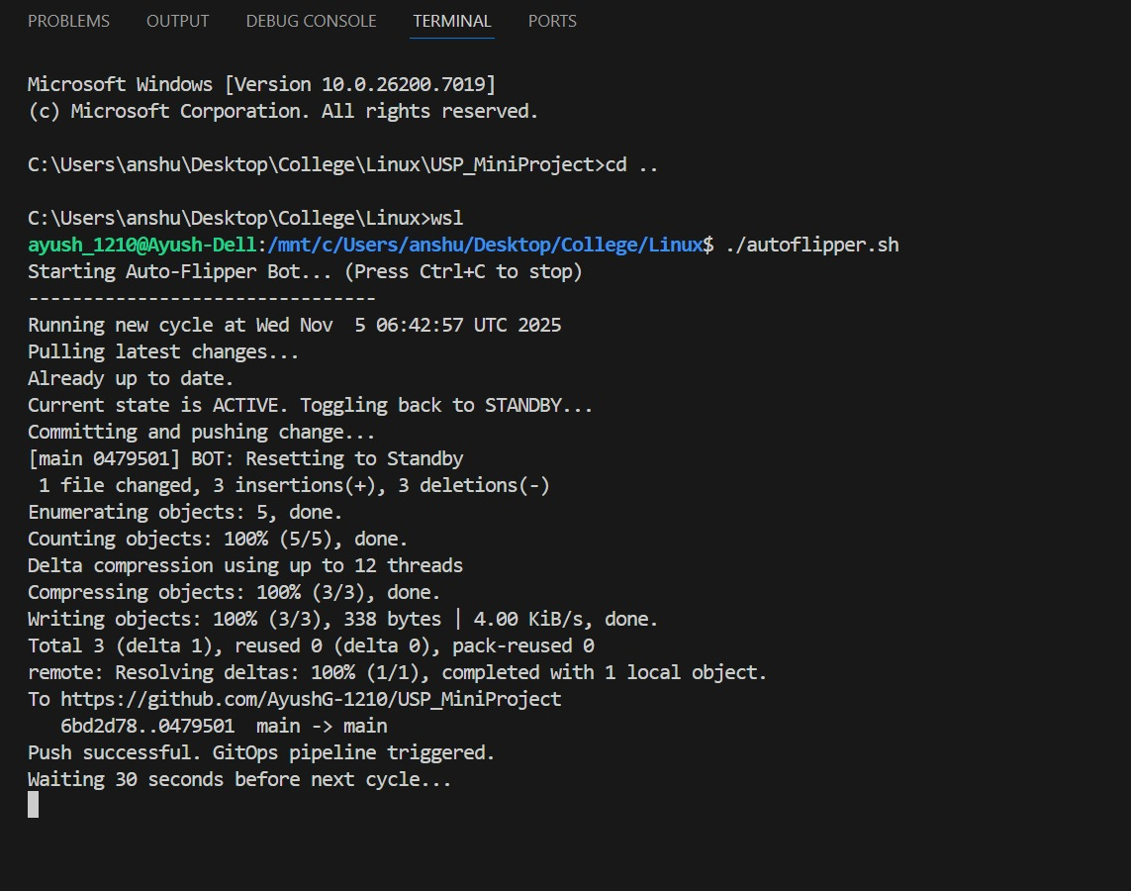
Figure 3: Auto-Flipper Execution and Git Operations
The third image captures the auto-flipper script in action, demonstrating the continuous integration loop:
- The script is executed from the Windows Command Prompt, showing cross-platform compatibility
- A complete cycle is shown starting at "Wed Nov 5 06:42:57 UTC 2025"
- The script successfully pulls the latest changes: "Pulling latest changes... Already up to date."
- State management is evident: "Current state is ACTIVE. Toggling back to STANDBY..."
- Git commit operation shows: "1 file changed, 3 insertions(+), 3 deletions(-)"
- The commit includes detailed Git statistics including object enumeration, counting, compression, and delta operations
- Push operation completes successfully to https://github.com/AyushG-1210/USP_MiniProject
- Commit hash "6bd2d78..0479501" indicates the main branch was updated
- Confirmation message: "Push successful. GitOps pipeline triggered."
- The cycle concludes with: "Waiting 30 seconds before next cycle..."
This demonstrates the full automation cycle: pull → check state → commit changes → push → trigger pipeline → wait → repeat.
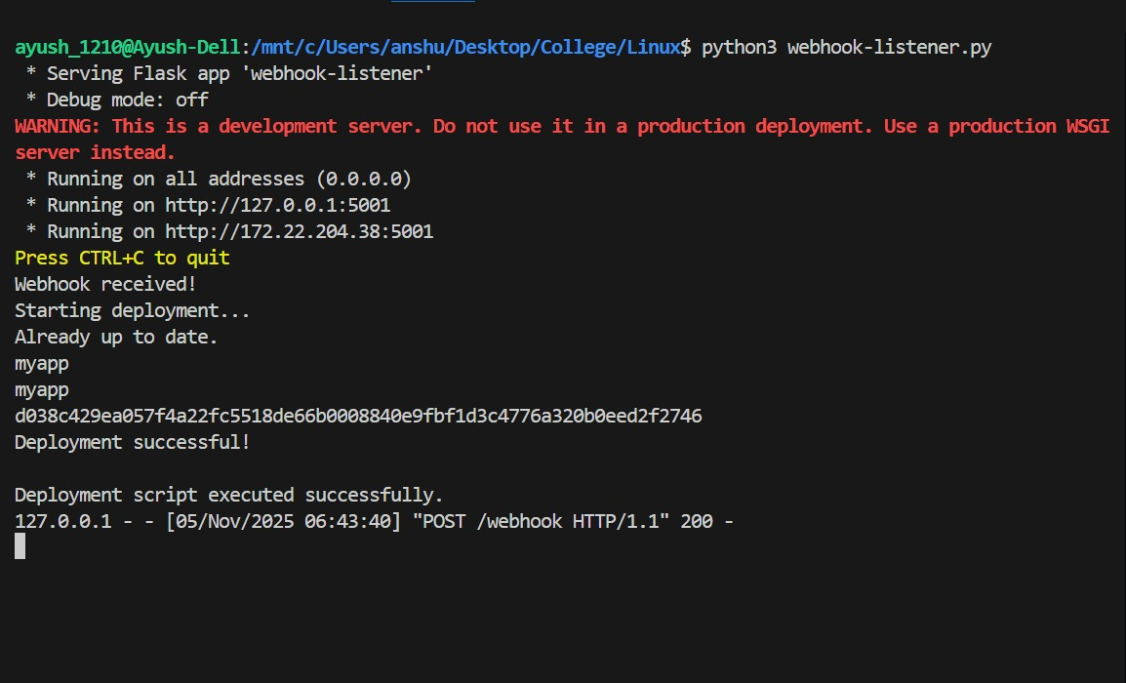
Figure 4: Webhook Reception and Deployment Execution
The fourth image shows the webhook listener receiving a trigger and initiating deployment:
- The webhook listener service is running and actively serving the Flask application
- A webhook is received: "Webhook received!"
- Deployment initiation message: "Starting deployment..."
- The system checks if the application is already up to date: "Already up to date."
- Application identifier is logged: "myapp"
- A deployment hash is generated for tracking: "d038c429ea057f4a22fc5518de66b0008840e9fbf1d3c4776a320b0eed2f2746"
- Successful completion message: "Deployment successful!"
- The Flask log shows the POST request: "127.0.0.1 - - [05/Nov/2025 06:43:40] "POST /webhook HTTP/1.1" 200 -"
The HTTP 200 response code confirms successful webhook processing. The deployment hash provides traceability for this specific deployment instance.
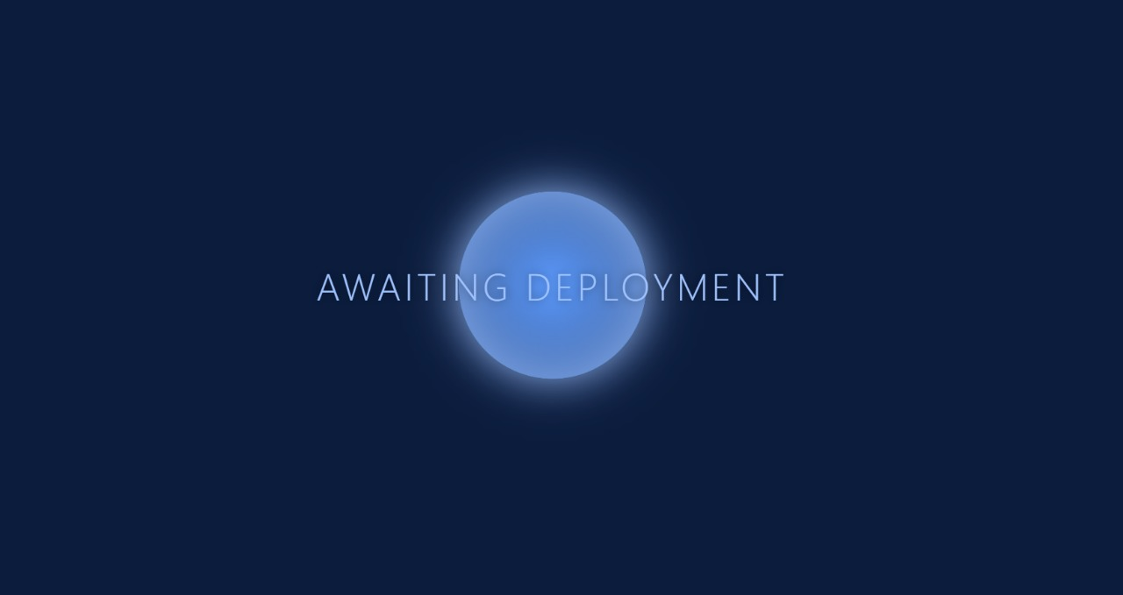
Figure 5: Deployment Status - Awaiting State
The fifth image presents the web interface in its waiting state:
- Clean, modern UI with a blue color scheme
- Central loading animation with a glowing circular element
- Large text displays: "AWAITING DEPLOYMENT"
- The minimalist design clearly communicates system status
This interface provides visual feedback to users monitoring the deployment process, indicating the system is ready and waiting for the next deployment trigger.
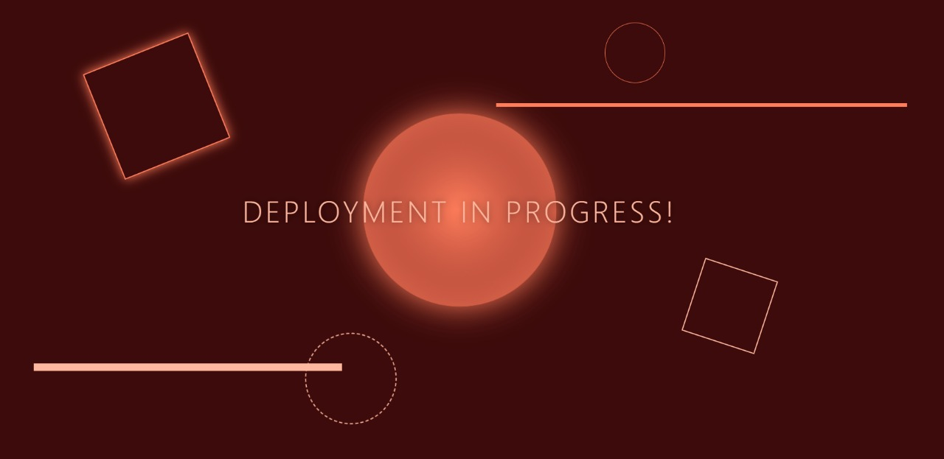
Figure 6: Deployment Status - Active State
The sixth image shows the web interface during active deployment:
- The color scheme transitions to warm tones (red/orange) to indicate activity
- Updated text displays: "DEPLOYMENT IN PROGRESS!"
- Loading animations include geometric shapes (squares, circles) with glow effects
- Progress indicator bars suggest ongoing operations
The visual transition from blue (idle) to red/orange (active) provides immediate, intuitive status feedback to users.
System Validation
These outputs collectively validate the core objectives and features of the system:
- Automated Webhook Reception: Figure 4 confirms webhooks are successfully received and processed.
- Continuous Git Synchronization: Figure 3 demonstrates the auto-flipper successfully pulling changes, committing updates, and pushing to the remote repository.
- State Management: The state toggle between ACTIVE and STANDBY in Figure 3 validates the state machine implementation.
- Network Accessibility: Figure 1 shows the ngrok tunnel providing external access to the local service.
- Deployment Execution: Figure 4 confirms deployment scripts execute successfully with proper validation and logging.
- User Interface Feedback: Figures 5 and 6 provide real-time status visualization for monitoring deployment workflows.
- Audit Trail: Git commit messages and hashes provide complete traceability of all automated operations.
- Error-Free Operation: All outputs show successful execution without errors, indicating robust implementation.
The system successfully implements a complete GitOps CI/CD pipeline with webhook-driven automation, continuous synchronization, and real-time monitoring capabilities. The automated workflow eliminates manual deployment steps while maintaining full visibility and control through comprehensive logging and visual interfaces.

CONCLUSION
The GitOps CI/CD Automation project successfully demonstrates the implementation of modern DevOps practices through automated deployment workflows. By combining webhook-driven event processing with continuous Git synchronization, the system provides a robust foundation for automated software delivery. The project validates that lightweight, script-based automation can effectively implement GitOps principles without requiring complex orchestration platforms or extensive infrastructure.
The system's architecture—utilizing Flask for webhook handling, bash for automation logic, and ngrok for secure tunneling—proves that effective CI/CD automation can be achieved with minimal dependencies and straightforward implementation. The real-time status monitoring through the web interface and comprehensive logging provide transparency and control over the deployment process.
While designed primarily for educational and development contexts, the project's modular architecture allows for extension to more complex scenarios including container orchestration, multi-environment management, and advanced deployment strategies. The successful validation through working prototypes demonstrates the practical viability of the approach and provides a template for similar automation implementations in various domains.

